**Abstract:**

The **ICTAK Internship Portal – Student View** is an innovative web-based platform designed to streamline and enhance the internship experience for students enrolled in ICT Academy of Kerala (ICTAK) programs. This portal serves as a centralized hub for students to manage their internship activities efficiently, from project selection to final submission and evaluation.

The portal provides a user-friendly interface enabling students to register, log in, and access a personalized dashboard. The dashboard displays project details, weekly reference materials, and submission links. Students can choose their internship topics, upload weekly progress reports, and submit their final project reports. Features such as a discussion forum foster collaborative learning by allowing students to post queries, share insights, and interact with peers and mentors.

The system ensures controlled access, with submission links becoming available only at specific intervals to maintain structured progress.

This application leverages the **MERN stack** (MongoDB, Express.js, React.js, Node.js) for a seamless, responsive, and scalable solution. Its focus on automation, transparency, and effective communication makes it an indispensable tool for managing internships, fostering skill development, and ensuring timely project completion.

**Flowchart:**

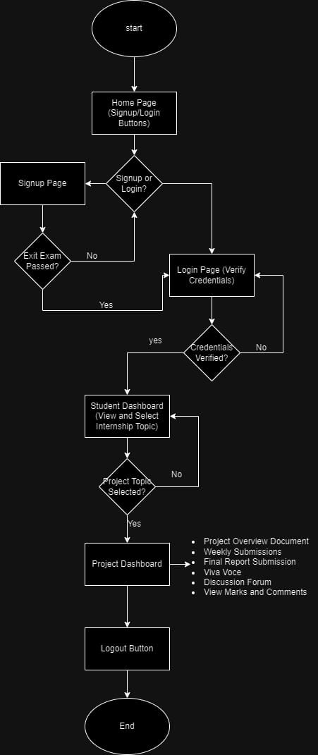

**DFD Level 0:**

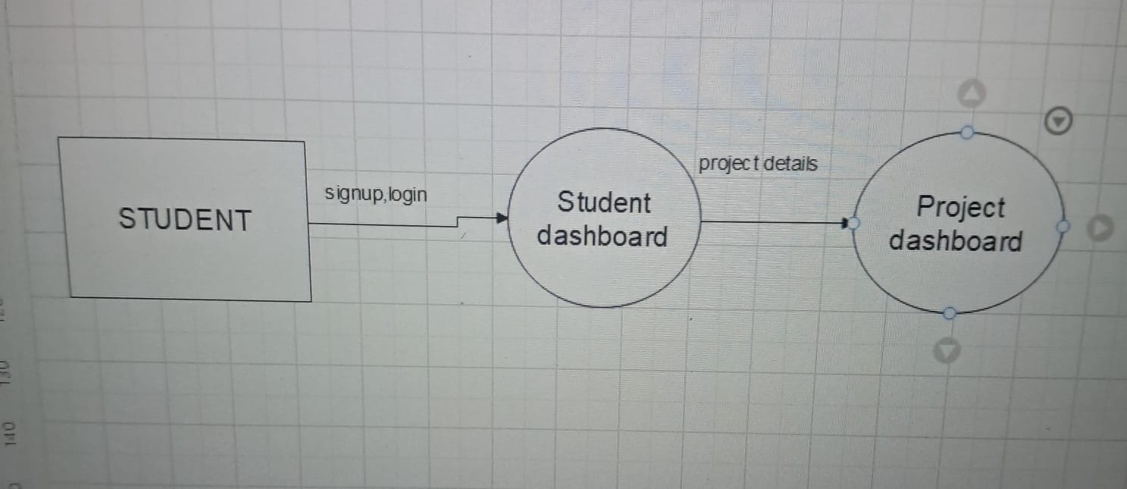

**Data flow Diagram level 2:**

Student

Add new user

user name and password

Pass mark in exit exam

New user record

Verification

student DB

Authorized

Weekly submissions

Final project submissions

Topic selected

Viva voce data

prevent multiple selection

Fetch Project topics

Project DB

Display project details

Discussion forum data

Fetch and display mark and comments

**Processes**

1. **Home Page**
   * Student navigates to the home page.
   * Displays **Sign Up** and **Login** options.
2. **Sign Up**
   * Student provides details (Name, Email, Password, Phone Number).
   * Exit exam result is validated.
   * Stores data in **Student Database**.
3. **Login**
   * Student enters credentials (Email, Password).
   * Validates credentials using **Student Database**.
   * Redirects to the **Student Dashboard** upon success.
4. **Student Dashboard**
   * **1.1 Display Project Topics**:
     1. Fetch project topics from the **Project Resources Database**.
   * **1.2 Select Project Topic**:
     1. Validate the selection and store it in the **Student Database**.
     2. Prevent multiple selections.
   * **1.3 Redirect to Project Dashboard**:
     1. Automatically transition the student to the project-specific dashboard.
5. **Project Dashboard**
   * **2.1 Display Project Details**:
     1. Fetch the project overview document from the **Project Resources Database**.
   * **2.2 Weekly Submissions**:
     1. Open submission links only at the end of each week.
     2. Allow students to upload files or submit links.
     3. Store submission data and comments in the **Student Database**.
   * **2.3 Final Project Submission**:
     1. Open final project submission at the end of the internship.
     2. Collect files and comments and store them in the **Student Database**.
   * **2.4 Viva Voce Preparation**:
     1. Display viva voce format.
     2. Open the submission link after the final project is submitted.
   * **2.5 Discussion Forum**:
     1. Allow students to post, edit, and comment on queries.
     2. Store forum data in the **Student Database**.
   * **2.6 View Marks and Feedback**:
     1. Fetch and display marks and feedback for each submission from the **Student Database**.

### **Key Data Flows**

* **Home Page → Sign Up**: Student enters details → Validates exit exam result.
* **Sign Up → Student Database**: Stores valid registration details.
* **Login → Student Database**: Verifies credentials → Redirects to Student Dashboard.
* **Student Dashboard**
  + Fetch topics from **Project Resources Database**.
  + Store selected topic in **Student Database**.
* **Project Dashboard**
  + Fetch project overview, reference materials, and submission formats from **Project Resources Database**.
  + Store weekly submissions, final project, viva voce data, and forum queries in **Student Database**.
  + Fetch marks and feedback from **Student Database**.

